Software Development

Label

Name: lblKingCommunication

Text: King Communication

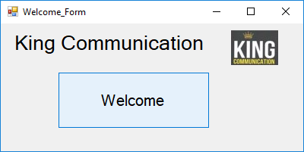

Picture

Name: PictureBox1

Text: No Text

Picture: Logo

Button

Name: btnWelcome

Text: Welcome

Labels

Name: lblUsername

Name: lblPassword

Name: lblLoginTittle

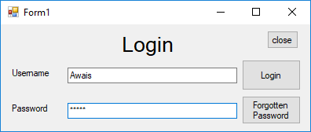

Text boxes

Name: txtUsername

Name: txtPassword

Button

Name: btnForgot

Text: Forgotten Password

Button

Name: btnLogin

Text: Login

Button

Name: btnClose

Text: Close

Labels

Name: lblMainMenu

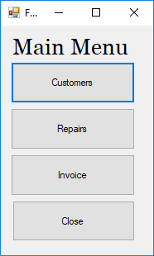

Buttons

Name: btnCustomers

Text: Login

Name: btnRepairs

Text: Repairs

Name: btnInvoice

Text: Invoice

Name: btnClose

Text: Close

Labels

Name: lblCustomersMenu

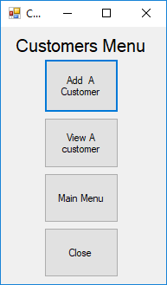

Buttons

Name: btnAddCustomerForm

Text: Add a customer

Name: btnShowCustomerForm

Text: View a customer

Name: btnMainMenu

Text: Main Menu

Name: btnClose

Text: Close

Text: Close

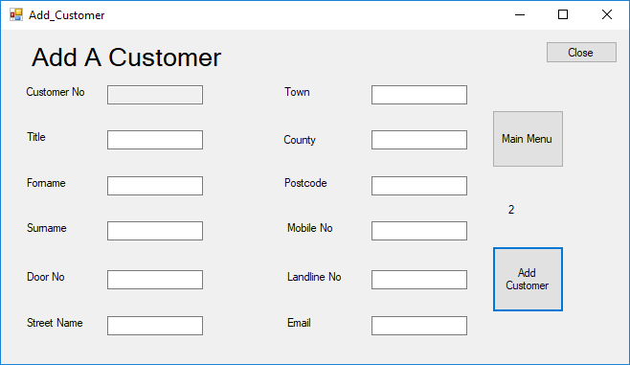

Labels

Label: lblAddACustomer

Label: lblCustomerNo

Label: lblTittle

Label: lblForename

Label: lblSurname

Label: lblDoorNo

Label: lblStreetName

Label: lblTown

Label: lblCounty

Label: lblPostcode

Label: lblMobileNo

Label: lblLandlineNo

Label: lblEmail

Text boxes

Name: txtCustomerNo

Name: txtTittle

Name: txtForname

Name: txtSurname

Name: txtDoorNo

Name: txtStreetName

Name: txtTown

Name: txtCounty

Name: txtPostcode

Name: txtMobileNo

Name: txtLandlineNo

Name: txtEmail

Buttons

Name: btnAddCustomerForm

Text: Repairs

Name: btnMainMenu

Text: Main Menu

Name: btnClose

Text: Close

|  |  |  |
| --- | --- | --- |
| Name | Type | Comments |
| Filename | string | Variable that stores the name of the customers file. |
| myformat | string | The spacing between the fields in the file. |
| NumberOfRecords | integer | How many records there are in the file. |
| OneCustomer | CutomerType | The structure that is in the module that holds all the public variables. |
| i | Short | The number of the record being viewed. |
| CharFirstName | Char | The result of the algorithm goes in this variable. |

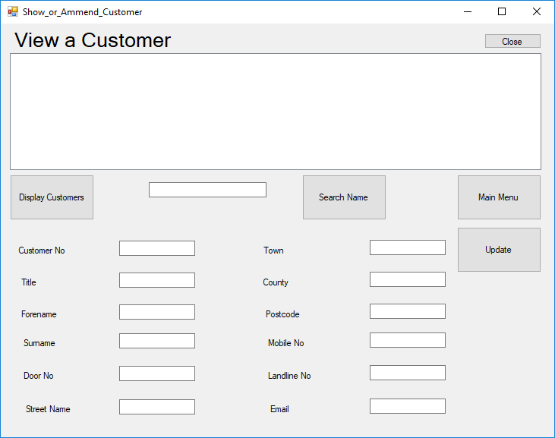

List box

Name: lstShowsTheCustomers

Buttons

Name: btnDisplayTheCustomers

Text: Display Customers

Name: btnMainMenu

Text: Main Menu

Name: btnClose

Text: Close

Name: btnNameSearch

Text: Search Name

Name: btnUpdate

Text: Update

Text boxes

Name: txtNameSearch

Name: txtCustomerNo2

Name: txtTittle2

Name: txtForname2

Name: txtSurname2

Name: txtDoorNo2

Name: txtStreetName2

Name: txtTown2

Name: txtCounty2

Name: txtPostcode2

Name: txtMobileNo2

Name: txtLandlineNo2

Name: txtEmail

Labels

Label: lblAddACustomer

Label: lblCustomerNo

Label: lblTittle

Label: lblForename

Label: lblSurname

Label: lblDoorNo

Label: lblStreetName

Label: lblTown

Label: lblCounty

Label: lblPostcode

Label: lblMobileNo

Label: lblLandlineNo

Label: lblEmail

|  |  |  |
| --- | --- | --- |
| Name | Type | Comments |
| Filename | string | Variable that stores the name of the customers file. |
| RecordPosition | integer | The position of a record in the file |
| Myformat | string | The spacing between the fields in the file. |
| listboxformat | string | The spacing between the fields in the file. |
| Index | Integer | The number of the record being viewed. |
| Finder | String | To store the data from the textbox into this variable. |
| Found | Boolean | To see if it’s found or not |

Labels

Name: lblRepairMenu

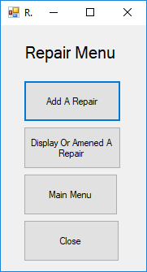

Buttons

Name: btnAddRepair

Text: Add a repair

Name: btnDisplayOrAmendARepair

Text: Display Or Amened A Repair

Name: btnMainMenu

Text: Main Menu

Name: btnClose

Text: Close

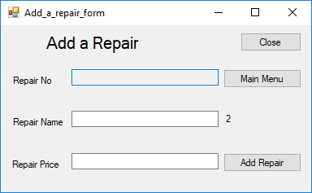

Textboxes

Name: txtRepairNo

Name: txtRepairName

Name: txtRepairPrice

Buttons

Name: btnAddRepair

Text: Add a repair

Name: btnMainMenu

Text: Main Menu

Name: btnClose

Text: Close

Labels

Name: lblAddARepairLogo

Name: lblRepairNo

Name: lblRepairName

Name: lblRepairPrice

Name: lblNoOfRecords

|  |  |  |
| --- | --- | --- |
| Name | Type | Comments |
| NameOfFile | string | Variable that stores the name of the customers file. |
| myformat | string | The spacing between the fields in the file. |
| NumberOfRecords | integer | How many records there are in the file. |
| oneRepair | RepairType | The structure that is in the module that holds all the public variables. |
| i | Short | The number of the record being viewed. |
| CharFirstName | Char | The result of the algorithm goes in this variable. |

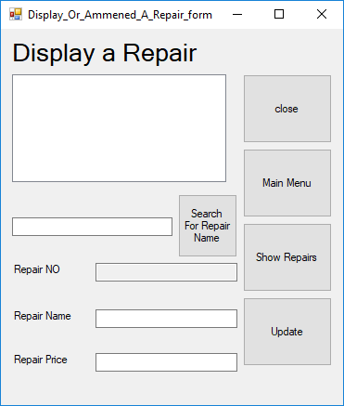

List box

Name: lstShowRepairs

Labels

Name: lblDisplayARepair

Name: lblRepairNo

Name: lblRepairName

Name: lblRepairPrice

Textboxes

Name: txtSearchRepair

Name: txtRepairNo

Name: txtRepairName

Name: txtRepairPrice

Buttons

Name: btnShowRepairs

Text: Show Repair

Name: btnUpdate

Text: Update

Name: btnMainMenu

Text: Main Menu

Name: btnClose

Text: Close

|  |  |  |
| --- | --- | --- |
| Name | Type | Comments |
| NameOfFile | string | Variable that stores the name of the customers file. |
| PositionOfRecord | integer | The position of a record in the file |
| Myformat | string | The spacing between the fields in the file. |
| Index | Integer | The number of the record being viewed. |
| Finder | String | To store the data from the textbox into this variable. |
| Found | Boolean | To see if it’s found or not |

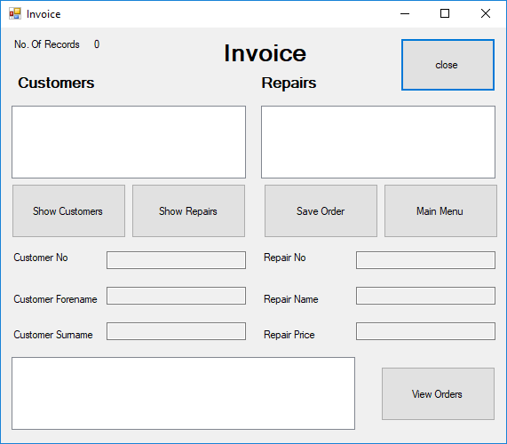

Text Box

Name: lblCustomers

Name: lblRepairs

Name: lblTextForNoOfRecords

Name: lblNumberOfRecords

Name: lblInvoiceLogo

Name: lblCustNo

Name: lblCustFor

Name: lblCustSur

Name: lblRepNo

Name: lblRepName

Name: lblRepPrice

Text Box

Name: txtCustNo

Name: txtCustFor

Name: txtCustSur

Name: txtRepNo

Name: txtRepName

Name: txtRepPrice

Buttons

Name: btnShowCustomer

Text: Show Customers

Name: btnShowRepair

Text: Show Repairs

Name: btnSave

Text: Save Order

Name: btnViewOrders

Text: View Orders

Name: btnMain

Text: Main Menu

Name: btnClose

Text: Close

List Box

Name: lstCustomerDetails

Name: lstRepairDetails

Name: lstViewOrders

|  |  |  |
| --- | --- | --- |
| Name | Type | Comments |
| NameOfFile | string | Variable that stores the name of the customers file. |
| Filename | String | Variable that stores the name of the repair file. |
| Order File | String | Variable that store the name of the order file. |
| PositionOfRecord | integer | The position of a record in the file. |
| RecordPosition | Integer | The position of a record in the file. |
| Orderpositionofrecord | Integer | The position of a record in the file. |
| Myformat | string | The spacing between the fields in the file. |
| Index | Integer | The number of the record being viewed. |
| Index3 | Integer | The number of the record being viewed. |